**EXPNO 7: CREATE A VIRTUAL MACHINE WITH 1 CPU, 2GB RAM AND 15GB STORAGE DISK USING A TYPE 2 VIRTUALIZATION SOFTWARE.**

**DATE**:1.10.2025

**AIM:**

To create a virtual machine with 1 cpu, 2gb ram and 15gbstorage disk using a type

2 virtualization software.

**PROCEDURE:**

STEP 1:Dowload VMware workstation and installed as type 2hypervisor.

STEP2:Dowload ubuntu or tiny OS as iso image file.

STEP 3: In VMware workstation->create new VM.

STEP 4: Do the basic configuration settings.

STEP 5: Created tiny OS virtual machine.

STEP 6: Launch the VM.

**IMPLEMENTATION:**

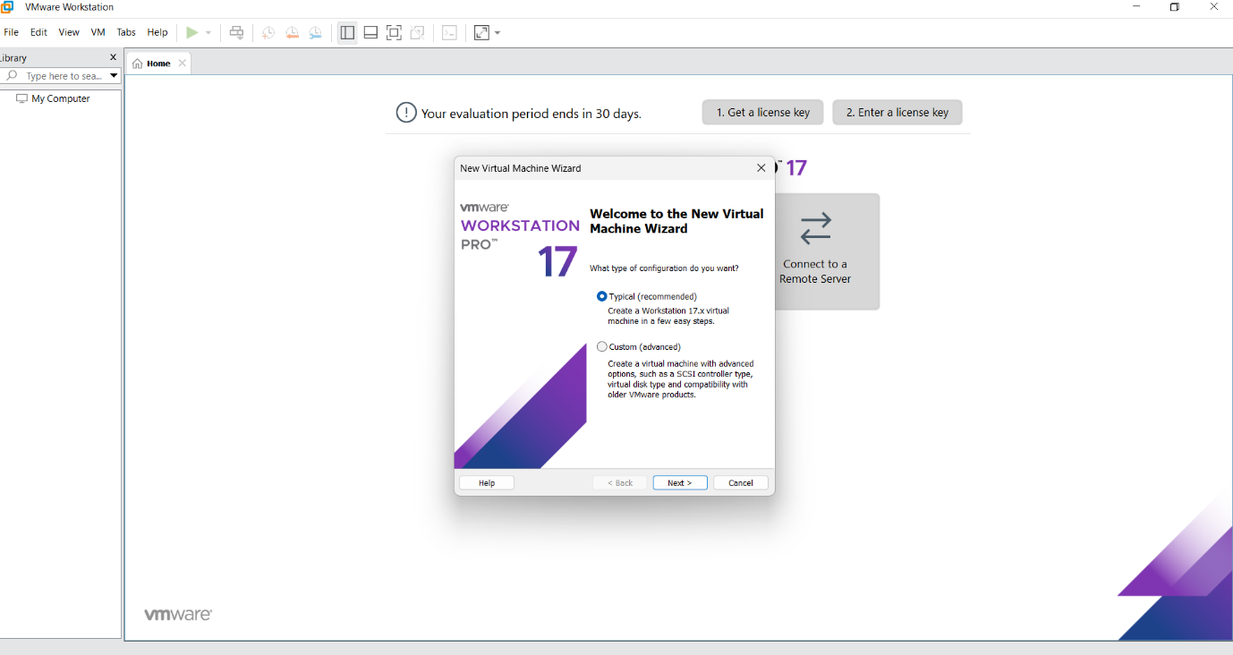

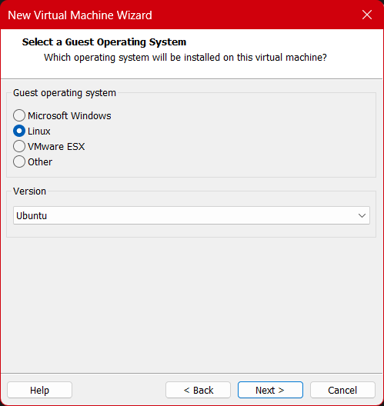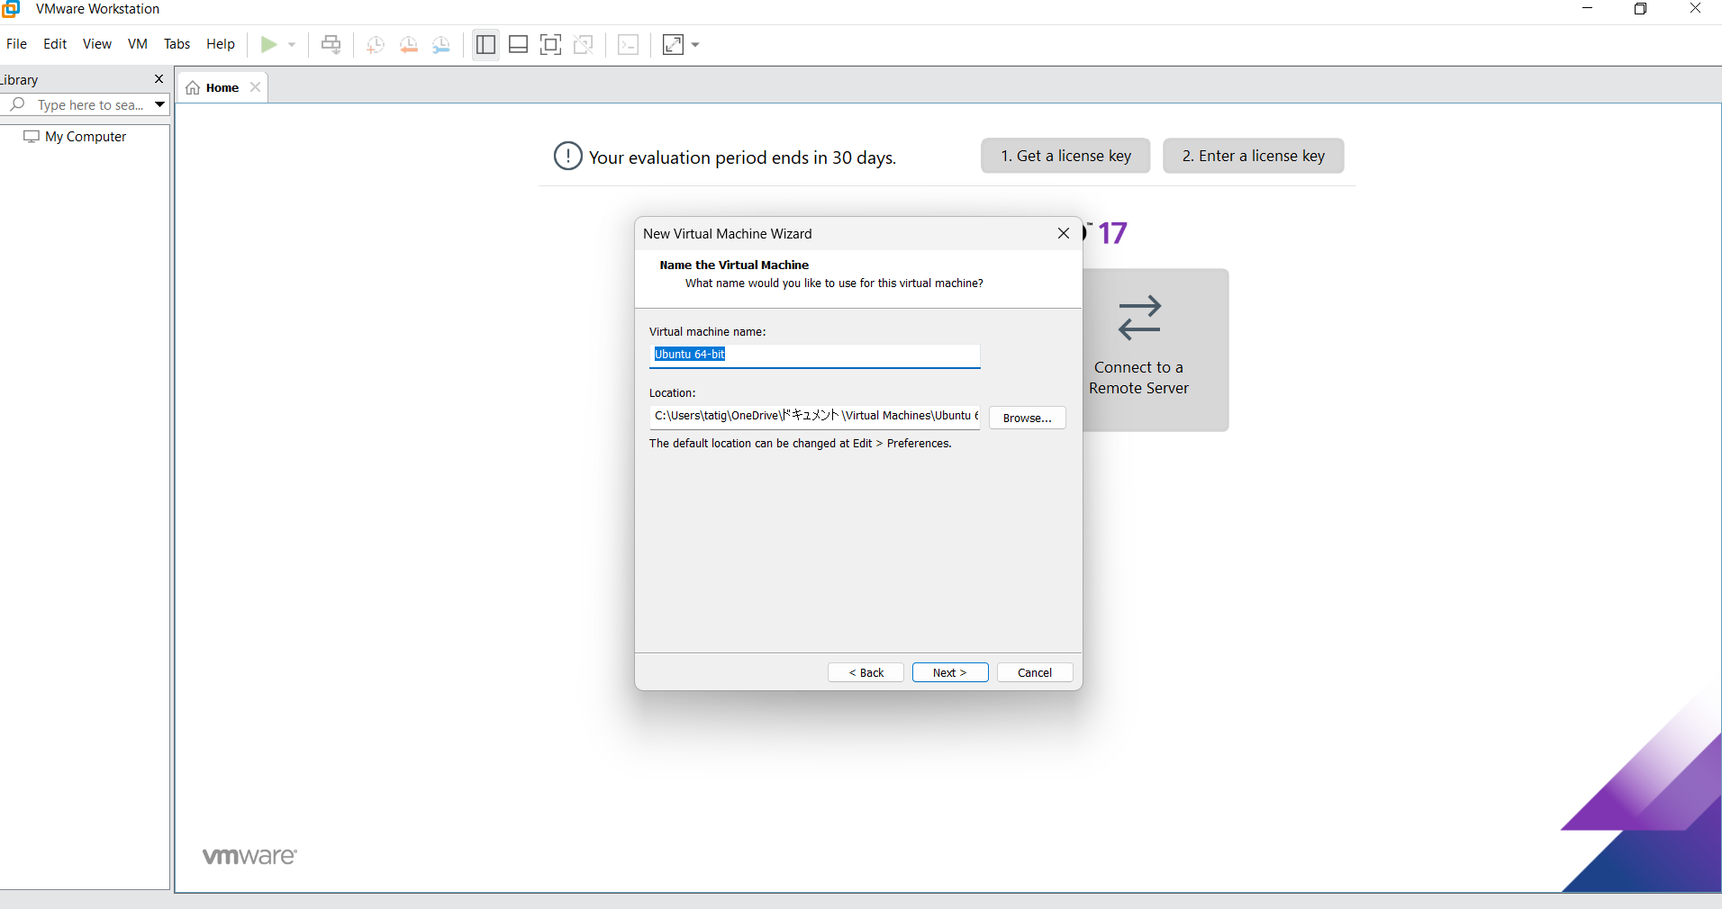

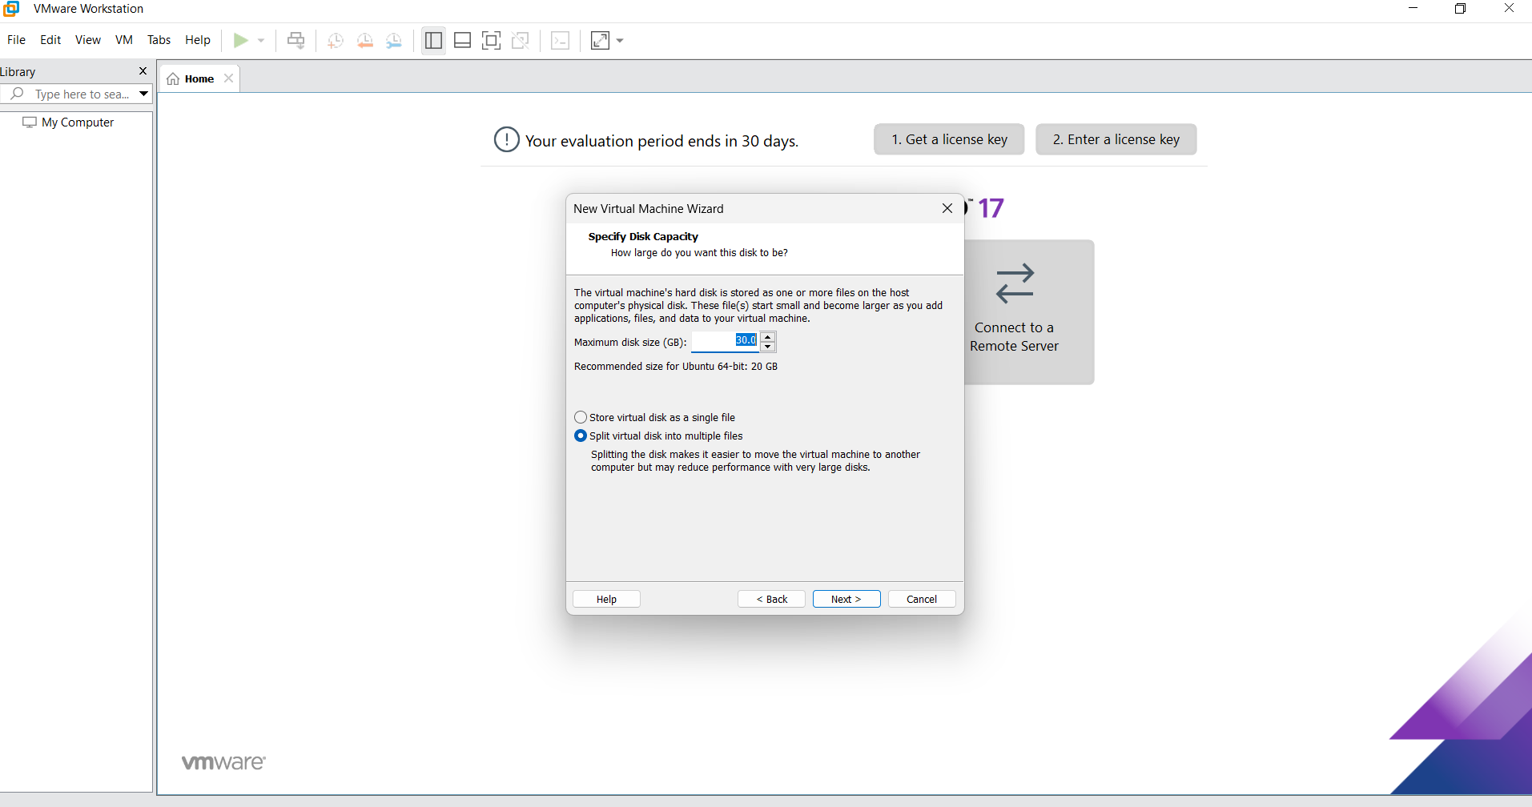

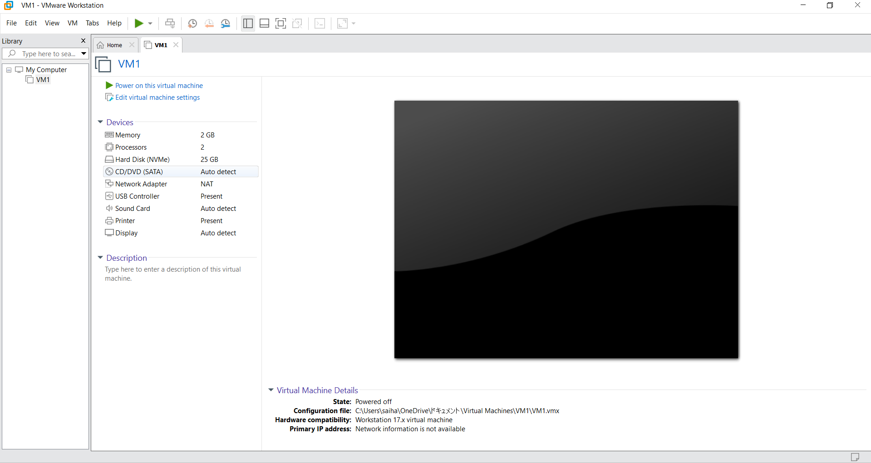

**Result:**

Virtual machine with 1 cpu, 2gb ram and 15gbstorage disk using a type

2 virtualization software has been created.